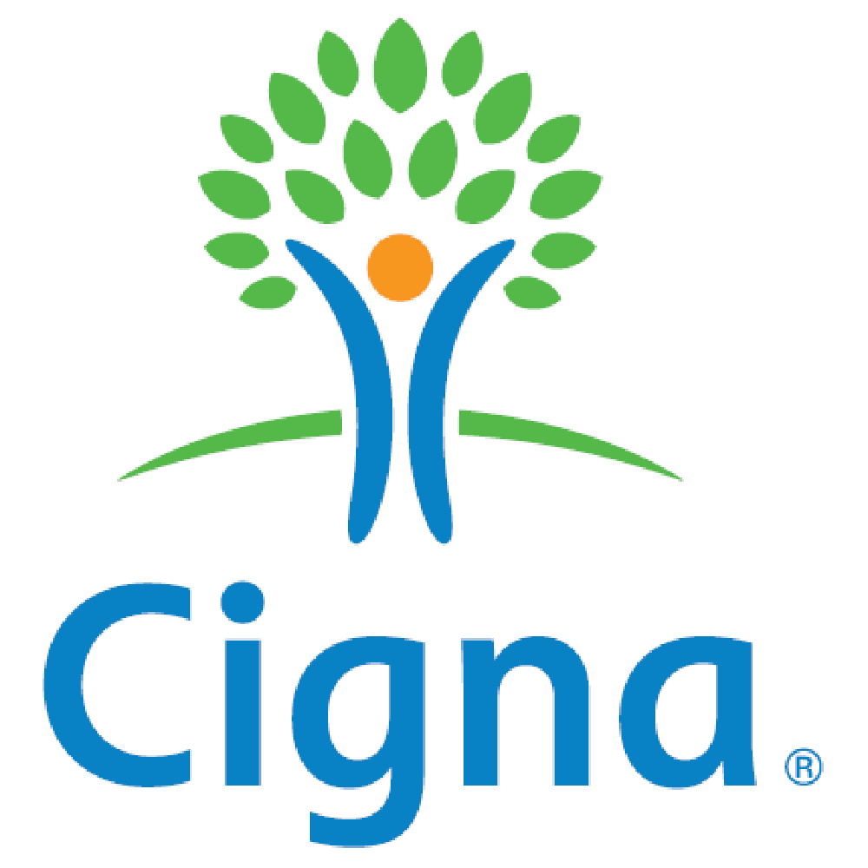

**Companion Guide**

**ASC X12N 834 (005010X220A1)**

**Benefit Enrollment and Maintenance: 834**

**Preface**

The Cigna Companion Guide supplements the HIPAA ASC X12N 834 (005010X220A1)

Implementation Guide for Benefit Enrollment and Maintenance.

**Disclosure Statement**

The information provided here is for reference use only, and does not constitute the rendering of legal, financial, or any other professional advice or recommendations by Cigna makes no representation or warranties of any kind in connection with the information provided herein, and hereby disclaims any other expressed or implied warranties, including implied warranties of merchantability or fitness for a particular use or purpose. “Cigna” is a registered service mark and the “Tree of Life” logo is a service mark of Cigna Intellectual Property, Inc., licensed for use by Cigna Corporation and its operating subsidiaries. All products and services are provided by or through such operating subsidiaries, including Connecticut General Life Insurance Company and Cigna Health and Life Insurance Company, and not by Cigna Corporation.

**Trading Partner Registration**

All trading partners who wish to submit Benefit Enrollment transactions to Cigna via the ASC X12 834 (Version 005010X220A1) must complete the Cigna 5010 Trading Partner form. Once the Eligibility Account Specialist submits off the transmission setup you will receive an email requesting you to complete a series of questions online. Trading Partner responses will provide Cigna contact information, desired connectivity method, and transaction-specific information. After completing all pertinent questions, Cigna will work with each Trading Partner to establish connectivity. Upon successful connectivity Cigna will begin system testing with each Trading Partner.

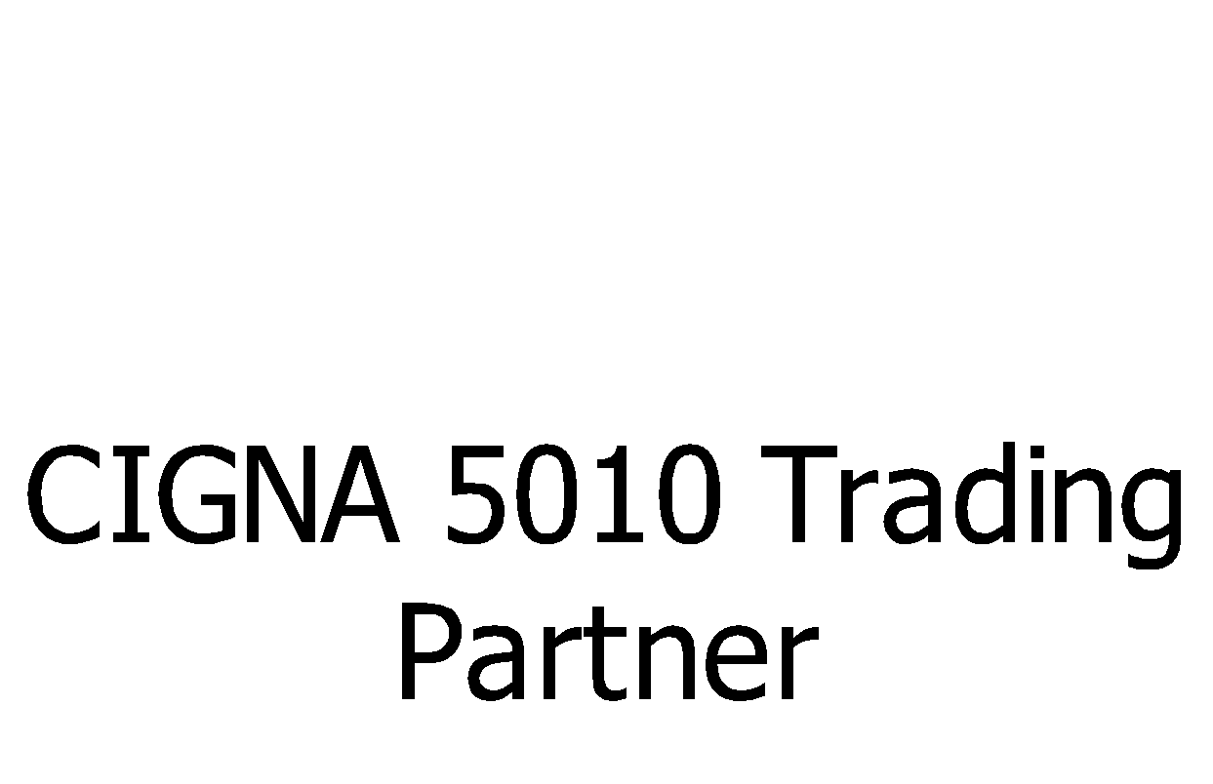

**System Availability and Downtime**

The 834 is available 24 hours a day, 7 days a week. To allow for maintenance, the 834 transactions may be unavailable on the first and third Sundays of the month from 6:00 p.m. until 10:00 p.m. ET. Batch files are queued for processing after the release window completes.

**Trading Partner Set Up Request Form**

Trading partners who have an active trading partner agreement are given IDs, passwords, and a URL to access the Cigna Technical Assessment Tool. Trading Partners will complete a minimum of three technical assessments to provide Cigna with their contact information, desired connectivity method, and transaction-specific information.

Trading partners should submit transactions according to current guidelines. Any questions regarding transmission must be submitted to Cigna EDI Customer Service.

Cigna offers the following transmission methods for securely exchanging batch transactions using the Cigna Gateway:

* HTTPS {PGP Optional}
* AS2 ─ EDIINT Automated HTTP(s)
* AS3 ─ EDIINT FTPS
* FTPS
* SSH/SFTP {PGP Optional}
* IBM Connect:Direct w/Secure+

**Please Note:** These are Cigna Standard offerings. If these methods cannot be applied, contact the Cigna Trading Partner help desk at [CHCTradingPartnerManagement@Cigna.com](mailto:CHCTradingPartnerManagement@Cigna.com) to schedule a meeting with a Cigna TPG representative.

After establishing a transmission method, each trading partner must successfully complete testing. Information on this phase is provided in the next section of this companion guide.

Before submitting production inbound files, each trading partner should be tested.

∙ Trading partners should test by uploading inbound X12 files to the self-service Cigna HIPAA Validation Tool. The tool analyzes files and generates reports listing any HIPAA validation errors encountered. Once test files successfully pass the Cigna HIPAA Validation Tool, trading partners should proceed to the next step to test a file through the Cigna system.

∙ Trading partners should test by submitting inbound X12 files and receiving validation from Cigna that the data in the file processes as expected. Trading partner testing includes HIPAA compliance testing as well as validating the use of conditional, optional, and mutually defined components of the transaction.

**Roles and Responsibilities:**

**Trading Partner:**

∙ Provide Cigna with accurate contact information.

∙ Complete the Technical assessments. This information will be used to set the trading partner up in the system.

∙ Coordinate testing with Cigna for the communication option selected.

**Cigna:**

∙ The Cigna Trading Partner Management team will contact your trading partner regarding any connectivity set-up/testing.

∙ Trading Partner communications of actual production date.

∙ Install changes based upon the pre-established Cigna production release procedures.

**Cigna Business Area/Application Technical Support:**

∙ Completion of data testing as needed

**Transmission Administrative Procedures**

Cigna will respond to 834 transmissions with a 999 (5010) if the transmission is rejected at the GS level. A 999 acknowledgement will be sent to indicate that a batch transaction has been accepted. A TA1 error response is dependent on information submitted within the inbound ISA field will be generated: If the value within the ISA14 element is a “0” then no TA1 will be generated even if the interchange is rejected. If the value within the ISA14 element is a “1” then a TA1 will be generated.

Cigna will provide you with a specific file name to upload to the Cigna gateway.

**Cigna Structure Processing**

Cigna recommends that the account structure be passed in the **2300 loop** of the ASC X12 834 (Version 005010X220A1). Your Cigna Eligibility Account Specialist will provide you with this account structure which will include – account number, branch, benefit option, and network information. The account number will consist of a 7 byte account number, followed by a 6 byte branch code, a 5 byte benefit option, and a 5 byte network code. If the branch code is less then 6 bytes, please left justify and space fill up to 6 bytes. Preceding the branch code will be a 5 byte benefit option code. If the benefit option is less than 5 bytes and there are no network codes, please end the segment after the last valid byte. Otherwise, left justify the benefit option code and space fill up to 5 bytes. The last field included would be the network code (if applicable).

Each product selected by the customer should be sent on the file. If they chose multiple products, the file would include multiple 2300 loops for each product.

Below is an example of how the Cigna structure should be passed in the REF*1L segment.

Bytes 1-7 Account Number

Bytes 8-13 Branch Code

Bytes 14-18 Benefit Option Code

Bytes 19-23 Network Code

7 bytes for the Account #, 6 Bytes spaced fill for Branch, and then 5 bytes or end right after the Benefit Option Code

Ex: Account number (1234567), Branch code (ACT), and Benefit Option Code (OAP) would look like - REF*1L*1234567ACT OAP~

Ex: Account number (1234567), Branch code (ACTIVE), Benefit Option Code (OAP), and Network code (TN808) would look like - REF*1L*1234567ACTIVEOAP TN808~

If you have the Health or Dependent Care products, Cigna will need additional information to be passed in the HD04. This information will consist of goal amounts, goal amount effective dates, and auto-claim forwarding indicators. Please see the attached document for passing this information.



**Cigna's 5010 834 File Format**

|  |
| --- |
| **R = Required (by ANSI or CIGNA)** |
| **S = Situational (CIGNA or Client Required)** |
| O = Optional (Client specific) |
| *X = Not used (by CIGNA)* |

|  |  |  |  |  |  |  |  |  |  |
| --- | --- | --- | --- | --- | --- | --- | --- | --- | --- |
| **Segment Code** | | **Element Name** | | **Required Status** | | **Cigna's Total # of bytes** | | **Values** | **Element Description** |
| **HEADER SEGMENTS** | | | | | | | | | |
| **ISA** | | **Interchange Control Header (Required)** | |  | |  | | Mapping Notes |  |
| ISA01 | | Authorization Information Qualifier | | R | | 2 | | 00 | 00 = Ignore ISA02 (No authorization information present) |
|  | | Element delimiter | | R | | 1 | | * | Asterisk (Suggested) |
| ISA02 | | Authorization Information | | R | | 10 | | (10 spaces) |  |
| ISA03 | | Security Information Qualifier | | R | | 2 | | 00 | 00 = Ignore ISA03 (No security information present) |
| ISA04 | | Security Information | | R | | 10 | | (10 spaces) |  |
| ISA05 | | Interchange ID Qualifier | | R | | 2 | | 30 | 30 = Federal Tax ID, ZZ = Mutually defined |
| ISA06 | | Interchange Sender ID | | R | | 15 | | **455147886** | Sender ID (owner of data, i.e. the client) - NOTE: Left justified, 15 bytes, space filled |
| ISA07 | | Interchange ID Qualifier | | R | | 2 | | 20 | 20 = Health Industry Number |
| ISA08 | | Interchange Receiver ID | | R | | 15 | | 029053964 | Receiver ID (CIGNA's HIN) - NOTE: Left justified, 15 bytes, space filled |
| ISA09 | | Interchange Date | | R | | 6 | | (YYMMDD) | Date the Interchange is created |
| ISA10 | | Interchange Time | | R | | 4 | | (HHMM) | Time the Interchange is created |
| ISA11 | | Repetition Separator | | R | | 1 | | ^ | Caret (Suggested) |
| ISA12 | | Interchange Control Version Number | | R | | 5 | | 00501 | 00501 = Usage of Standards Approved by ACS X12 Review Board |
| ISA13 | | Interchange Control Number | | R | | 9 | | (Generated Number 1) | Unique Serial Number for each Interchange (see IEA02) Must be 9 characters long. |
| ISA14 | | Acknowledgment Requested | | R | | 1 | | 0 | 1 = TA1 requested, 0 = No TA1 requested |
| ISA15 | | Usage Identifier | | R | | 1 | | P or T | P = Production, T = Test |
| ISA16 | | Component Element Separator | | R | | 1 | | : | Colon (suggested) |
|  | | Segment terminator | | R | | 1 | | ~ | Tilde (Suggested) |
| The “>” (greater than) or “<” (less than) characters should not be used as the Segment, Element, Repetition Separator (ISA11), or component Element Separator (ISA16) delimiters as this will cause an application failure for certain files and cause a delay in the processing of the file. | | | | | | | | | |
| **Segment Code** | **Element Name** | | **Required Status** | | **Cigna's Total # of bytes** | | **Values** | | **Element Description** |
| **GS** | **Functional Group Header (Required)** | |  | |  | |  | |  |
| GS01 | Functional Identifier Code | | R | |  | | BE | | BE = Benefit Enrollment And Maintenance (834) |
| GS02 | Application Sender's Code | | R | |  | | **455147886** | | Fed Tax ID of the Sender (Client…not TPA). This is the unique key code of the file. |
| GS03 | Application Receiver's Code | | R | |  | | 029053964 | | CIGNA's HIN |
| GS04 | Date | | R | |  | | (CCYYMMDD) | | Date the Group Header is created. |
| GS05 | Time | | R | |  | | (HHMM) | | Time the Group Header is created. Also valid: (HHMMSSDD), (HHMMSS) |
| GS06 | Group Control Number | | R | |  | | (Generated Number 2) | | Unique serial number assigned by sender (see GE02) 1 to 9 (Number) |
| GS07 | Responsible Agency Code | | R | |  | | X | | X = ASC X12 |
| GS08 | Version/Release/Industry Identifier Code | | R | |  | | 005010X220A1 | | Approved by ACS X12 Review Board |
|  |  | |  | |  | |  | |  |
| **ST** | **Transaction Set Header (Required)** | |  | |  | |  | |  |
| ST01 | Transaction Set Identifier Code | | R | |  | | 834 | | 834 = Benefit Enrollment and Maintenance |
| ST02 | Transaction Set Control Number | | R | |  | | (Label 1) | | Unique label assigned by sender (see SE02) Must be 4 to 9 alpha numerics EA: 0001 ST02 must match SE02 |
| ST03 | Implementation Convention Reference | | R | |  | | 005010X220A1 | | This must match the GS08 |
|  |  | |  | |  | |  | |  |
| **BGN** | **Beginning (Required)** | |  | |  | |  | |  |
| BGN01 | Transaction Set Purpose Code | | R | |  | | 00 | | 00 = Original File |
| BGN02 | Reference Identification | | R | |  | | (Label 2) | | Unique label assigned by sender 1 to 30 (alpha numeric) |
| BGN03 | Date | | R | |  | | (CCYYMMDD) | | Date the Transaction Set is created. |
| BGN04 | Time | | R | |  | | (HHMMSSDD) | | Time the Transaction Set is created. |
| BGN05 | Time Code | | O | |  | | (null) | | Time code is not necessary |
| BGN06 | Reference Identification | | S | |  | | (null) | | Suggested that client not use since BGN01will always indicate original file |
| *BGN07* | *Transaction Type Code* | | *Not Used* | |  | | *(null)* | | Not Used |
| BGN08 | Action Code | | R | |  | | RX | | RX = full file (CIGNA preference); 4 = Verify, or 2 = Change file, valid in some cases |
|  |  | |  | |  | |  | |  |
| **1000 LOOP** | | | | | | | | | |
| **N1** | **Sponsor Name (Required)** | |  | |  | |  | |  |
| N101 | Entity Identifier Code | | R | |  | | P5 | | P5 = Sponsor (A sponsor is the party that ultimately pays for the coverage, benefit, or product. No TPA information here) |
| N102 | Name | | O | |  | | Vendor Credentialing Services | | Client Name |
| N103 | Identification Code Qualifier | | R | |  | | FI | | FI = Federal Tax ID (This segment can be hardcoded) |
| N104 | Identification Code | | R | |  | | **455147886** | | Federal Tax ID of Plan Sponsor (Client) |
|  |  | |  | |  | |  | |  |
| **N1** | **Payer (Required)** | |  | |  | |  | |  |
| N101 | Entity Identifier Code | | R | |  | | IN | | IN = Insurer |
| N102 | Name | | O | |  | | CIGNA | | Insurer Name |
| N103 | Identification Code Qualifier | | R | |  | | FI | | FI = Federal Tax ID (This segment can be hardcoded) |
| N104 | Identification Code | | R | |  | | 06-0303370 | | CIGNA's Tax ID |
|  |  | |  | |  | |  | |  |
|  |  | |  | |  | |  | |  |
| **2000 LOOP** | | | | | | | | | |
| **INS** | **Member Level Detail (Required)** | |  | |  | |  | |  |
| INS01 | Yes/No Condition or Response Code | | R | | 1 | | Y or N | | Y = Subscriber (Employee) or N = Non-Subscriber (Dependent) |
| INS02 | Individual Relationship Code | | R | | 2 | | If employee, send 18  if ConRelationship = SPS or DP, send 01  if ConRelationship = CHD, CHL, DPC or STC, send 19 | | 01 = Spouse, 18 = Self, 19 = Child (all other codes are valid) |
| INS03 | Maintenance Type Code | | R | | 3 | | 030 | | All codes are valid, but CIGNA will treat all transactions as '030' |
| INS04 | Maintenance Reason Code | | R | | 2 | | XN | | If INS03 = 030, then INS04 can be 'XN' |
| INS05 | Benefit Status Code | | R | | 1 | | A | | Active, COBRA, or Surviving Insured |
| **Segment Code** | **Element Name** | | **Required Status** | | **Cigna's Total # of bytes** | | **Values** | | **Element Description** |
| INS06 | Medicare Plan Code | | S | | 1 | | E | | A = Medicare Part A, B = Part B, C = Parts A&B, D = Medicare, E = No Medicare |
| INS07 | COBRA Qualifying | | S | | 2 | | Leave blank | | If INS05 = C, then 1 = Terminated. (must be populated if INS05 is a C.) |
| INS08 | Employment Status Code | | R (O) | | 2 | | AC | | AC = Active, FT = Full-Time, RT = Retiree (Required for Subscriber, Optional for Dependents) |
| INS09 | Student Status | | S | | 1 | | F | | F = full-time, N or Null = Not a Student (For Dependents over max Child age only) |
| INS10 | Yes/No Condition or Response Code | | S | | 1 | | If ConIsDisabled = Y, send Y, else send N | | Y = Handicapped, N or Null = Not Handicapped (For Dependents over max Child age only) |
| INS11 | Date Time Period Format Qualifier | | S | |  | | D8 | | D8 = CCYYMMDD |
| INS12 | Date Time Period | | S | | 8 | | EepDateDeceased or ConDeathDate | | (CCYYMMDD) |
|  |  | |  | |  | |  | |  |
| **REF** | **Subscriber Number (Required)** | |  | |  | |  | |  |
| REF01 | Reference Identification Qualifier | | R | |  | | 0F | | 0F = Subscriber Number -- NOTE: it is "zero-eff", not "oh-eff" |
| REF02 | Reference Identification | | R | | 9 | | (EE's SSN) | | EepSsn |
| **2100A LOOP** | | | | | | | | | |
| **NM1** | **Member Name (Required)** | |  | |  | |  | |  |
| NM101 | Entity Identifier Code | | R | |  | | IL | | IL = Insured -- NOTE: it is "eye-el", not "one-el" |
| NM102 | Entity Type Qualifier | | R | |  | | 1 | | 1 = Person |
| NM103 | Name Last or Organization Name | | R | | 30 | | EepNameLast or ConNameLast | | Last Name of member |
| NM104 | Name First | | R | | 15 | | EepNameFirst or ConNameFirst | | First Name of member |
| NM105 | Name Middle | | O | | 1 | | 1st digit of EepNameMiddle or ConNameMiddle | | Middle Initial of member |
| **Segment Code** | **Element Name** | | **Required Status** | | **Cigna's Total # of bytes** | | **Values** | | **Element Description** |
| NM106 | Name Prefix | | O | | X | | (null) | | CIGNA will ignore |
| NM107 | Name Suffix | | O | | 3 | | (null) | | CIGNA will ignore |
| NM108 | Identification Code Qualifier | | S | | 2 | | 34 | | 34 = SSN |
| NM109 | Identification Code | | S | | 9 | | eepSSN or ConSSN   If dependent SSN is not available, do not send 34 in NM108 | | SSN of member (NM108 and NM109 must either both be present or neither be present) |
|  |  | |  | |  | |  | |  |
| **PER** | **Member Communications Numbers (Optional - CIGNA will load this information if provided)** | | | | | | | | |
| PER01 | Contact Function Code | | O | |  | | IP | | IP = Insured Party |
| *PER02* | *Name* | | *X* | |  | | leave blank | | Not Used |
| PER03 | Communication Number Qualifier | | O | |  | | HP | | if EepPhoneHomeNumber blank, move up EM and eepAddressEmail to PER03 and PER04 positions if both are blank, leave PER line off file |
| PER04 | Communication Number | | O | | 10/50 | | EepPhoneHomeNumber | | Phone Number in AAAEEENNNN format |
| PER05 | Communication Number Qualifier | | O | |  | | EM | |  |
| PER06 | Communication Number | | O | | 10/50 | | eepAddressEMail | |  |
|  |  | |  | |  | |  | |  |
| **N3** | **Member Residence Street Address (Required for Subscriber - Ignored on Dependents)** | | | | | | | | |
| N301 | Address Information | | R *(X)* | | 30 | | EepAddressLine1 | | Subscriber's Address line 1 (Required for subscribers, CIGNA will ignore on Deps) |
| N302 | Address Information | | S *(X)* | | 30 | | EepAddressLine2 | | Subscriber's Address line 2 (CIGNA will read subscriber and ignore dependents) |
|  |  | |  | |  | |  | |  |
| **N4** | **Member Residence City, State, Zip Code (Required for Subscriber - Ignored on Dependents)** | | | | | | | | |
| N401 | City Name | | R | | 20 | | EepAddressCity | | City Name (Read on subscriber, ignored on dependents) |
| N402 | State of Province Code | | R | | 2 | | EepAddressState | | State (Read on subscriber, ignored on dependents) |
| N403 | Postal Code | | R | | 9 | | EepAddressZipCode | | Zip Code - 5 or 9 digits (Read on subscriber, ignored on dependents) |
|  |  | |  | |  | |  | |  |
| **DMG** | **Member Demographics (Required)** | |  | |  | |  | |  |
| DMG01 | Date Time Period Format Qualifier | | R | |  | | D8 | | D8 = CCYYMMDD |
| DMG02 | Date Time Period | | R | | 8 | | EepDateOfBirth | | Date of Birth |
| DMG03 | Gender Code | | R | | 1 | | EepGender, send U if blank | | Female, Male, or Unknown Gender Code -- NOTE: CIGNA will load U as M |
| **Segment Code** | **Element Name** | | **Required Status** | | **Cigna's Total # of bytes** | | **Values** | | **Element Description** |
| DMG04 | Martial Status Code | | O | | 1 | | if eepMaritalStatus does not equal S or M, send blank, else send eepMaritalStatus | | M = Married, S = Single (CIGNA will load these values if provided. Other values ignored) |
|  |  | |  | |  | |  | |  |
| **2300 LOOP** | | | | | | | | | |
| **HD** | **Health Coverage (Required)** | |  | |  | |  | |  |
| HD01 | Maintenance Type Code | | R | | 3 | | 030 | | 030=Audit (CIGNA treats all values as audit) Same as INS03. |
| *HD02* | *Maintenance Reason Code* | | *X* | | *X* | | *(null)* | | Not Used |
| HD03 | Insurance Line Code | | R | | 3 | | If eeddedcode = DEN1 or DEN2 send DEN else send HLT | | HLT, DEN, VIS, MM, PPO, POS, HMO |
| HD04 | Plan Coverage Description | | S | | 50 | | See account structure | | Plan Coverage Description (if FSA products are included please see the FSA products tab) – Benefit Option code on account structure |
| HD05 | Coverage Level Code | | R (X) | | 3 | | If EedBenOption = EE, send EMP  if EedBenOption = EES or EEDP, send ESP  if EedBenOption = EEC or EECH send ECH  if EedBenOption = EEF or EEDPF, send FAM | | Coverage Code (Required for Subscriber, *not for Dependent*) |
|  |  | |  | |  | |  | |  |
| **DTP** | **Health Coverage Dates (Required)** | |  | |  | |  | |  |
| DTP01 | Date/Time Qualifier | | R | |  | | 348 | | 348 = Benefit Begin (Always Required) Please see Business Rules tab on effective date impacts. |
| DTP02 | Date Time Period Format Qualifier | | R | |  | | D8 | | Date Expressed in Format CCYYMMDD Qualifier |
| DTP03 | Date Time Period | | R | | 8 | | EedBenStartDate | | Benefit Begin Date |
| DTP01 | Date/Time Qualifier | | S | |  | | 349 | | 349 = Term date (Required when terming a member completely) |
| DTP02 | Date Time Period Format Qualifier | | S | |  | | D8 | | Date Expressed in Format CCYYMMDD Qualifier |
| DTP03 | Date Time Period | | S | | 8 | | EedBenStopDate | | Benefit End Date |
| **REF** | **Health Coverage Policy Number (Situational - CIGNA's preferred placement of structure and or plan codes)** | | | | | | | | |
| REF01 | Reference Identification Qualifier | | S | |  | | 1L | | 1L = Group or Policy Number |
| REF02 | Reference Identification | | S | | 30 | | See account structure | | Plan codes as defined by CIGNA and agreed on by client (preferred placement) – map based on codes on account structure  Bytes 1-7 Account Number  Bytes 8-13 Branch code (left justify and space fill if applicable)  Bytes 14-18 Benefit Options (end segment after benefit option, otherwise left justify and space fill if network code is passed)  Bytes 19-23 Network code |
|  |  | |  | |  | |  | |  |
| **TRAILER SEGMENTS** | | | | | | | | | |
| **SE** | **Transaction Set Trailer (Required)** | |  | |  | |  | |  |
| SE01 | Number of Included Segments | | R | |  | | (count) | | Count of segments in transaction set including ST and SE |
| SE02 | Transaction Set Control Number | | R | |  | | (Label 1) | | Same label as in ST02 |
|  |  | |  | |  | |  | |  |
| **GE** | **Functional Group Trailer (Required)** | |  | |  | |  | |  |
| GE01 | Number of Transaction Sets Included | | R | |  | | (count) | | Count of All Transaction Sets in Functional Group |
| GE02 | Group Control Number | | R | |  | | (Generated Number 2) | | Same number as in GS06 |
|  |  | |  | |  | |  | |  |
| **IEA** | **Interchange Control Trailer (Required)** | |  | |  | |  | |  |
| IEA01 | Number of Functional Groups Included | | R | |  | | (count) | | Count of All Functional Groups in Interchange |
| IEA02 | Group Control Number | | R | |  | | (Generated Number 1) | | Same number as in ISA13 |

**Transaction Examples and Business Rules**

Attached are the transaction examples and business rules.



**General Processing Rules**

Attached is Cigna's General Processing Rules.

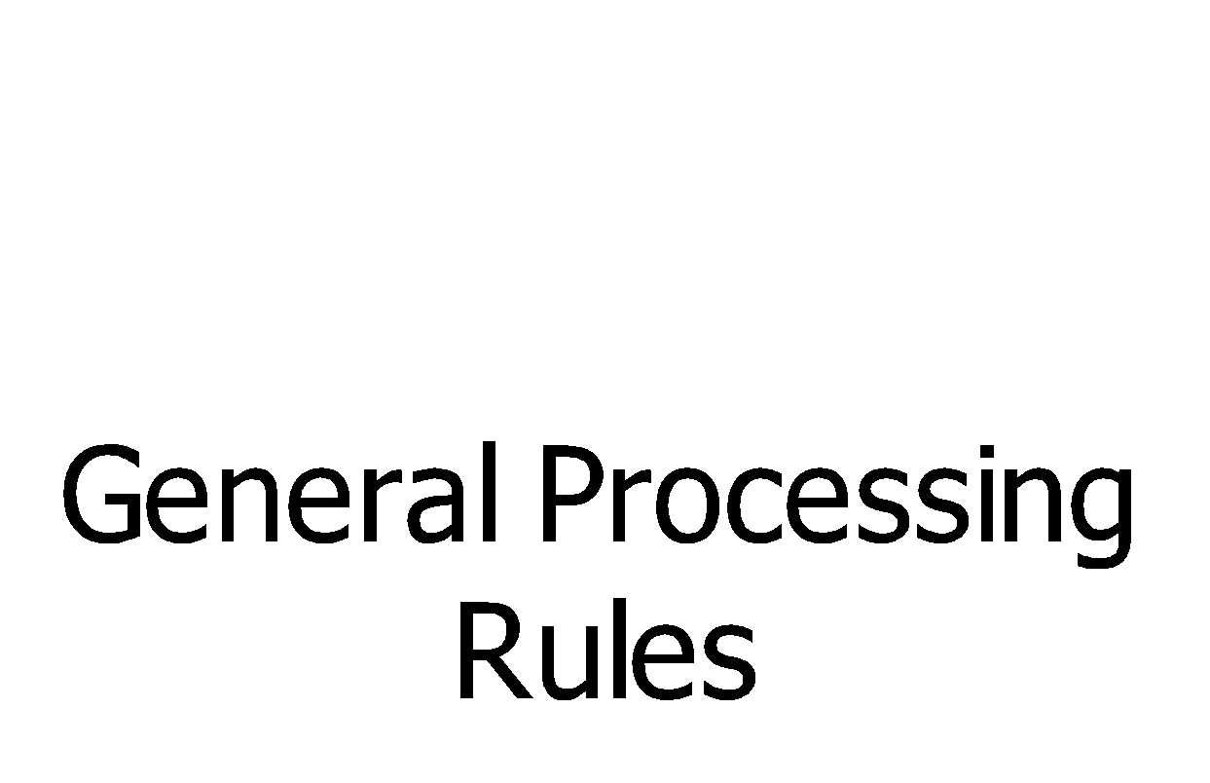

**Acknowledgements and Reports**

Cigna will generate the TA1/999 acknowledgement for all inbound x12 transactions. The Trading Partner must setup an outbound transmission with Cigna, and you will receive the TA1/999 through that outbound transmission. Otherwise the Trading Partner will have to pick up the TA1/999 from Cigna’s server.

No CIGNA specific requirements were created for the 5010 999 transactions. The standard HIPAA TR3 guides are available to download from the Washington Publishing website at <http://www.wpc-edi.com/>.